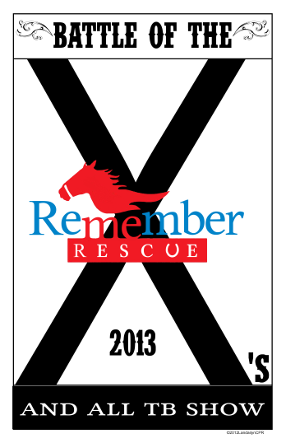 | 2013 Battle of the X’s –  The Trainers Challenge  And All Thoroughbred Horse Show
SPONSOR LEVELS
PLATINUM $5000 ___________
DIAMOND $3000 ___________
GOLD $1500 ___________
SILVER $1000 ___________
BRONZE $ 500 ___________
RED $ 100 ___________
WHITE $ 50 ___________
BLUE $ 25 ___________
Platinum through Bronze levels will have their logos on all print materials (flyers, posters and print ads). Their names will be announced via PA System numerous times during the show and will receive prominent placement in our show program.
You can pay for your sponsorship two ways – either via paypal on our website (www.teamkeen.com) or via check made out to Remember Me Rescue.. Please check the level at which you wish to sponsor and return the form to: Remember Me Rescue, 4100 Conveyor Drive, Burleson, Texas 76028 Sponsorships are due by 2-15-13 to make print deadlines. Please submit a copy of your logo to remembermerescue@live.com so we can include it in our print material. Also please let us know if you have signage you would like to hang in the arena.

