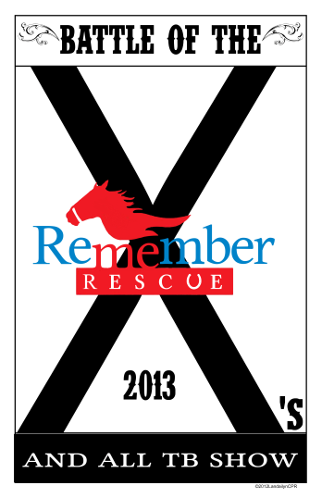 | 2013 Battle of the X’s –  The Trainers Challenge  And All Thoroughbred Horse Show  Sponsor Information

The mission of Remember Me Rescue is to improve the quality of life and to assist retired and injured racehorses after their careers at the track are over. Remember Me Rescue also works with authorities in numerous states when horse seizures, relating to abuse or neglect of a horse, takes place. Once a Thoroughbred arrives at Remember Me Rescue it is checked out and if necessary treated by our veterinarian. Once the horse is determined to be health they begin the retraining journey which includes desensitization and being ridden regularly. Thoroughbreds make wonderful trail companions, lesson horses, mounted patrol horses, jumping or dressage horses. These special horses can be retrained for nearly anything. Remember Me Rescue is a 501(C)(3) organization.
Please help us continue our mission to retrain the horses donated to our program and give them the opportunity to have wonderful lives after the track.
Battle of the X’s – The Trainers Challenge and Thoroughbred Horse Show is an opportunity to show how Race Horses can be trained in different disciplines after their race track careers are over. To be a part of this great event become a Sponsor.
You can pay for your sponsorship two ways:
Via Check (make check payable to Remember Me Rescue):
Mail check to: Remember Me Rescue
4100 Conveyor Dr.
Burleson, Texas 76028

Via Paypal:
Go to www.teamkeen.com/battleofthexsottb/levelsponsorship

For Platinum through Red levels of sponsorship the deadline is February 15, 2013, to ensure you are listed in our printed materials. For Platinum through Gold levels of sponsorship logos may be submitted to remembermerescue@live.com.

Please complete the attached form and mail it to Remember Me Rescue at the address listed above.

For Office Use Only
Payment Received: | Logo Received: |  | Signage Provided:
Sponsors Name: |  | Contact Name: |  | Email Address:

Mailing Address: | Cell Phone:
 | Office Phone:
 | Fax Number:

SPONSORSHIP LEVELS
€ Platinum Level - $5,000
Logos on all printed materials (flyers, posters and print ads)
Logo on the Remember Me Rescue website
Signage (provided by you) to be hung in the arena
Names announced numerous times during the show and challenge
Prominent placement in our show program

€ Diamond Level - $3,000
Logos on all printed materials (flyers, posters and print ads)
Logo on the Remember Me Rescue website
Signage (provided by you) to be hung in the arena
Names announced numerous times during the show and challenge
Prominent placement in our show program

€ Gold Level - $1,500
Listed on all printed materials (flyers, posters and print ads)
Logo on the Remember Me Rescue website
Signage (provided by you) to be hung in the arena
Names announced numerous times during the show and challenge
Placement in our show program

€ Silver Level - $1,000
Listed on all printed materials
Listed on the Remember Me Rescue website
Signage (provided by you) to be hung in the arena
Listed in our show program

€ Bronze Level - $500
Listed on all printed materials
Listed on the Remember Me Rescue website
Listed in our show program

€ Red Level - $100
Listed on the Remember Me Rescue website
Listed in our show program

€ White Level - $50
Listed on the Remember Me Rescue website

€ Blue Level - $25
Listed on the Remember Me Rescue website

